OUR STORY

As Time Goes By 1
Founding Fathers: the Evolution of a Club 2
Hail to the Chief 8
Location Location Location 9
The Show Must Go On 11
The Orators 33
Road Trip 34
The Fifth Estate 42
Fun, Friends and Frivolity 48
Community Involvement 53
We The People 59

The Buffalo Geological Society was founded in 1938. Its purpose is to bring together people that enjoy learning, studying, collecting and sharing in a friendly atmosphere their common interest in the geological sciences and related fields such as Minerology, Paleontology and the Lapidary Arts. This is accomplished with an Annual Show, a Banquet, a Picnic and swap, many Field Trips and educational and entertaining Monthly Programs that end with a social coffee hour.

This is our STORY….…

- Although the Buffalo Society of Natural Sciences conducted classes and study groups in geology as far back as 1892, the earliest known attempt to formalize a local Geology Club within the Society came in 1920:
“There was a geological Hobby club with study sections under the direction of expert instructors reported in May 1920. James Storer was chairman.”

March 18 1969 Correspondence by Dr. Virginia L. Cummings

- While the historical information is sketchy, and a number of groups formed and disbanded between 1920 and 1938 the first meeting of an organization deemed a “Section” of the Society came about in 1930:
“The Geological Section held its first meeting on Thursday, February 6, 1930 at the Museum. Plans for the future of the Club were discussed. The tentative program included field trips, exhibition of collections made by Club members, occasional lectures and an opportunity for the cooperative investigation of the various phases of local geology.”

Hobbies Magazine March 1930 by John T. Sanford

- Even so, this precursor body to our organization, though calling itself a “Section”, didn’t receive formal recognition as such until 1932.

- This group and other related groups continued to come and go and merge together until February 2, 1938. On this date our present day organization was officially established and recognized by the Society as the “Geological Section of the Buffalo Society of Natural Sciences”

- The BGS became affiliated with the Buffalo Society of Natural Sciences as an annual dues paying member in 1940.

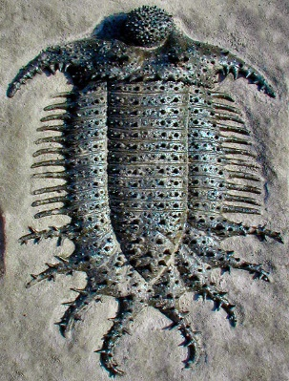
- The first Constitution and By-Laws were enacted on November 26, 1941, at which time the club had a paid membership of 36. Speakers that year included Irving G. Reimann, Edwin Roedder and Max Kopf. That year, the Club also adopted the large trilobite Terataspis grandis as its first symbol.

- From its founding until the onset of World War II the Geological Section was one of the most active organizations in the Buffalo Society of Natural Sciences. It then went essentially dormant in 1943 until re-convening again on February 28, 1946.

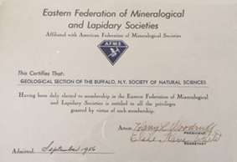

- By 1956 our organization became large enough and active enough to be elected to membership in the Eastern Federation of Mineralogical and Lapidary Sciences at their convention held in Baltimore on Sept 28, 1956.

- The organization was officially incorporated on June 27, 1960. The name of the proposed corporation was “The Geological Section of the Buffalo Society of Natural Sciences” The paperwork was submitted to the state on February 25, 1960 by club officers: Clifford Awald, Thaddeus J. Czarniejewski, Donald A. Armistead, Carol Heubusch and Elmer W. Zimmerman.

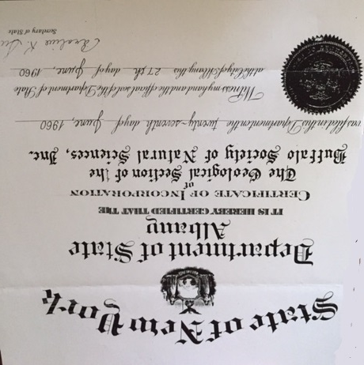

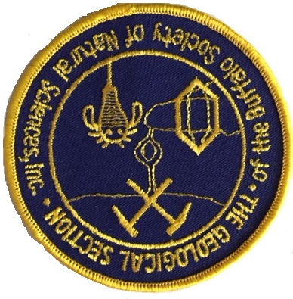

- A new emblem was created and adopted in 1964. The design was the work of club member and Museum Curator Carol Heubusch.

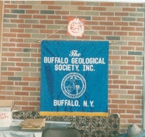

- The club purchased its first banner in March 1977 at a cost of $125.00. An updated version of the blue and gold silk flag can be seen at the Annual Gem Show, club picnic and all meetings and events at which the club participates.

- Also in 1977 Mineral and Fossil Study groups were established to enhance the club’s already education based program of speakers and field trips. A combination of these two groups still meets today.

- A Certificate of Amendment, authorizing the change of name to “The Buffalo Geological Society, Inc.” was accepted for filing by the Department of State, and became official as of December 14, 1982. The amendment was submitted by club officers Joseph Butch and Gertrude Hird on November 11, 1982. The legal process was handled by club member Morgan Jones and Jerry Bastedo. Initial motion for the change was made a year earlier at the November 1981 Board meeting to then President Donald Armbruster by Board member Marvin Hess, seconded by Jerry Bastedo. The motion was tabled to be voted on at the December meeting.

- A Library was established in 1983 by Joe Butch which today holds 100 plus books and over 700 bulletins and publications available to all members free of charge.

- A second Certificate of Amendment was enacted in 2004, in order to comply with 501(c)(3) regulations which formally gave our club the status of a non-profit organization. It added Article 8 to our constitution:
“No part of the net earnings of the corporation shall insure to the benefit of any director or officer of the corporation.”

Revisions to our constitution over time has resulted in this statement being incorporated into Article 4 of our current constitution.
- Our current Constitution was enacted on April 3, 2009. The key revisions added flexibility for the Board and Officers. All term limits were removed as well as preassigned responsibilities for the various Officer positions.

- Although our members spend a good deal of time digging up the past, our club entered the age of technology in 2003. In his Newsletter column for November of that year, then President Dale Russell extended “A belated thank you to Gerry Wochadlo for all of the time and hard work he put in to kick start a club web page.” The format has changed with the technology many times since then with the current format being launched in October 2011. The original Web Master, Ron Maciak was followed by Jan Barton in 2013 and Miriam Eastham in 2018.

- Our presence on Facebook launched in April 2014.

- From its early days with under 50 members our club grew steadily to today’s count of 237 members.

- As our membership grew so did our treasury. While dues barely cover the club’s operating expenses, the growth of the annual Gem Show can be directly correlated to the growth of our coffers. Balances under $70.00 and as low as $13.00 were typical through the 1950’s and earlier. The treasury did finally cracked $100 in 1957 but it was not until 1970 that it reached $1,000. While there were many lean years in between, club finances stabilized in the 1980’s. The late 1990’s showed a dramatic rise based primarily on show profits and our bank balance has been healthy ever since.

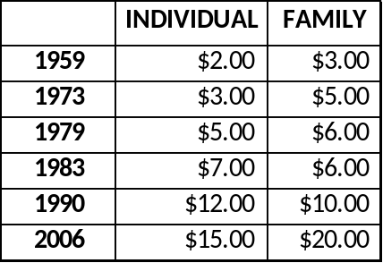
- Dues were initially set at $1.00 per year in 1938. Since then they increased modestly over time to meet expenses. With the initial increase in 1959 a “Family” category was added to help defray the cost to members. A student category was also created at that time but was phased out in 1973.

- In a 1991 GEOLETTER article then President Bob Hoffman explained how your dues are used:
Printing (10 issues at $0.33 each) 3.30
Mailing (10 issues at $0.29 each) 2.90
Federation Dues ($1.00 per person) 1.00
Club Insurance ($1.05 per person) 1.05
Meeting Hall Rental 1.25
9.50
The remainder is included in the general fund and used, in part, for the following: to subsidize the coffee and donuts at monthly meetings, travel for program speakers, picnic grove rental, picnic beverages and corn and subsidizing the annual banquet. It is estimated that the normal cost of running the Club is $12.50 per person

Dues at the time were $10.00/Individual and $12.00/Family.

GEOLETTER May 1991 Where Does It GO? by Bob Hoffman
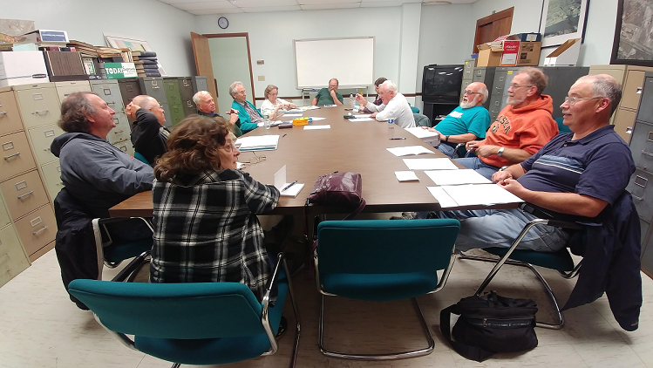

Your Officers and Board 2017-2018
Clockwise from the front Marcia Binda , Steve Birtz, Paul Leuchner, Jerry Bastedo, William Broad, Marilyn Broad, Craig Posmantur, Joseph Sullivan, Alan Wilds, Dick Phillips, Dale Russell and Don Lapham III. Missing: Charlie Ferguson, Larry Wolfe. Photo taken by Director Miriam Eastham.
- Since inception 35 different members have served as President of the organization.
- O.C. Whitman holds the record for the most consecutive terms in office with 5, from 1942 to 1947.
- Robert J Hoffman, the only President elected three different times, held the most non-consecutive terms in history, serving for 8 terms.
- David and Gloria Rote are the only husband and wife team to both serve as President.
- Fred Sievenpiper was the only President to also serve as President of the EFMLS.
- Clifford J. Awald was the only President to also be elected President of the Buffalo Society of Natural Sciences (1978).
- Jerold C. Bastedo was also elected the first president of both the Hamburg Natural History Society and Buffalo Association of Professional Geologists.

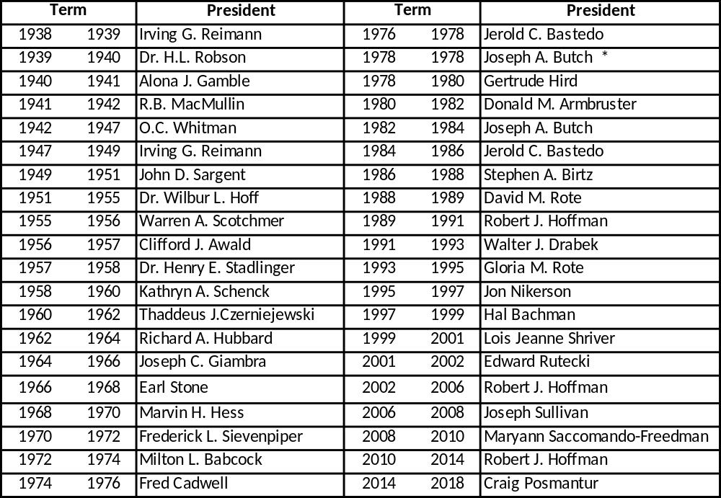

* Served only a partial term in 1978

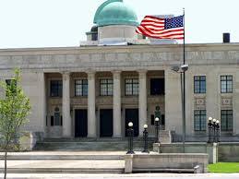

- From its beginning until January 15, 1989 the Society held all its meetings at the Buffalo Museum of Science, using the old Humboldt Room for all its regularly scheduled meetings.

- During construction of the attached Science Magnet school in 1989 the BGS was forced to temporarily move its meeting place. For 3 meetings (February, March and April) the club met in a classroom at Mckinley High school.

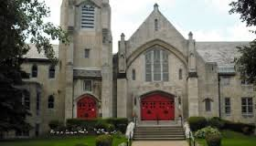
- When the construction timeline for the new school was extended the Board was forced to find more suitable long term facilities. As a result, starting in October 1989 meetings were held at the Parkside Lutheran Church in Buffalo.

- In October 1991 the Board officially decided not to return to the Museum as a meeting place
“A return to the Museum became a viable option this year and the pros and cons were actively debated. The Board took a number of factors into account in arriving at its decision, one of the most important of which was the input it received from the membership. Also considered were security, parking availability, suitability of meeting rooms for special activities, conflicts with other events and accessibility. The decision to remain at the Church was not an easy one, and should in no way be viewed as a severance of our ties with the Museum.”

GEOLETTER October 1991 As I See It by Walter Drabek
- Just a month later a last minute scheduling problem at the Church (Philharmonic concert) forced the November 1991 meeting back to the Museum. But this was a one-time move and the Club continued to meet at the Church through April 2017.

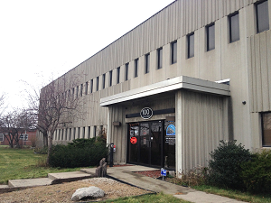
- Starting with the October 2017 meeting, the club’s new “permanent” home became the Heritage Discovery Center at 100 Lee Street, Buffalo NY. The inaugural meeting was held on October 6 and was well attended by over 60 members and guests. The featured speaker Dr. Nathan Jud of Cornell University, spoke to over 70 people on paleobotany in Patagonia. The meeting was jointly attended by members of the Niagara Frontier Botanical Society.

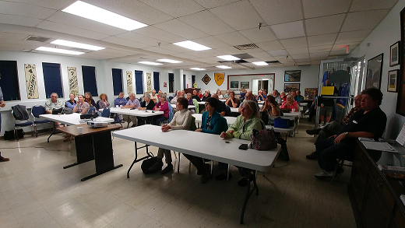

  - Our inaugural show dates back to March 19, 1966. Held in the Showroom of Lou Awald Chevrolet in Kenmore (currently Paddock Chevrolet), admission was free and less than 10 dealers were invited to participate.

- The next year 1967 saw the show move to the VFW Amherst Township Post 416 in Williamsville, and again admission was free.

- There were no shows held from 1968 through 1970, but in April 1970 Marvin Hess was named chairman of a committee charged with re-establishing the show in 1971.

- In 1971 the show returned, this time at the ECC cafeteria in Clarence and began an unbroken string of annual shows that continues through today.

- The Show lasted 1 more year at ECC then in 1973 was housed at the Hutchinson Hose Fire Hall in Williamsville.

- 1974 saw a move to the Harvey D. Morin Post in West Seneca where it remained through 1988. The next year a scheduling conflict at the Post forced a move to another facility.
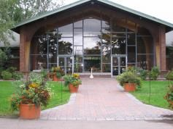
- In 1989 under the leadership of Chairman Jerry Bastedo, the show moved to the Erie County Fairgrounds, where it occupied the Grange Building.

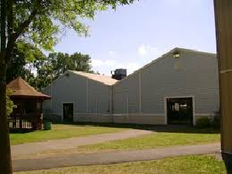

- In an effort to expand and raise additional revenues a second building, the Marketplace building was added in 2002 expanding the number of dealers to 25.

- 2016 saw addition of yet a third building, the NY State Police building.

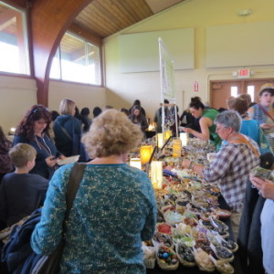
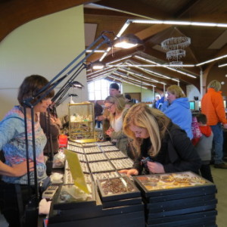

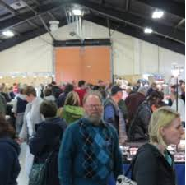

Jam packed show crowd examining a large selection of dealer ware

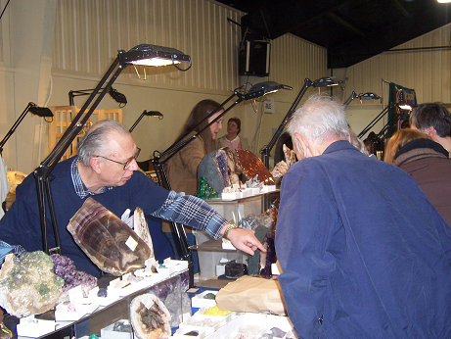
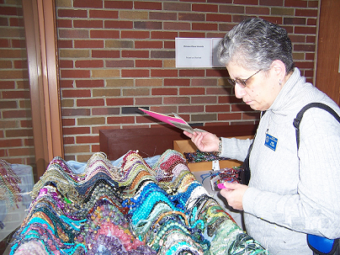

Diane Butch inspects a huge cache of beads Gerry Wochadlo points out specimen to a visitor

ADMISSION
After 2 years of FREE admissions the entry fee rose modestly over the years to meet rising costs.

FROM | TO | ADMISSION
1971 | 1974 | $0.25
1975 | 1978 | $0.50
1979 | 1992 | $1.00
1993 | 1997 | $3.00
2001 | 2007 | $4.00
2008 | PRESENT | $5.00
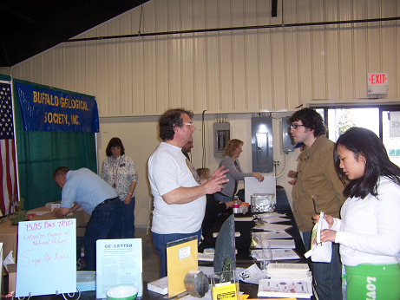

Patricia Giordano-Birtz, Steve Birtz and others working the Admissions Table.

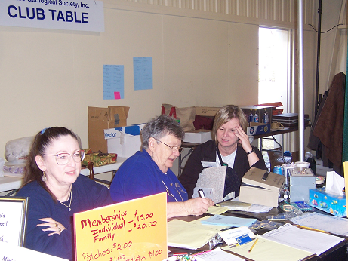

Lois Shriver, Ruth Banick and Jan Barton working the Club Table

TEAM WORK
- The success of every show depends on the time and effort of our members. Over the years hundreds of volunteers have staffed the Mini Mine, Gandpa’s Corner, the Admissions and Club tables and Demonstration Booths. Countless hours have been spent coordinating dealers, non-profit partners, member exhibitors, advertising, security and the logistics of setup and breakdown.

- During its formative years 1966-1973, Marvin Hess and Joe Giambra took the lead as chairs and laid the foundation for future successes. Both gentlemen remained active well into the 1990’s chairing various show committees.

- Over the years, several long time members have stepped up to the plate and chaired our show on a short term basis when called upon. These included: Gerry Kloc, Walter Drabek, Fred Cadwell and Keith Rowe.

- Four stalwarts, however, have shouldered the responsibility of chairing our show for several consecutive years. Lead by Jerry Bastedo who holds the record for leading the effort 14 times during the 1980’s and 1990’s, the group also includes: Robert Hoffman, Steve Birtz and Fred Sievenpiper. Jerry, incidentally, was back at the helm again chairing this year’s 50th Anniversary show.
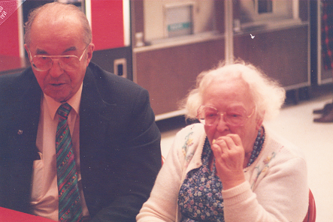

Fred (President, Show Chair, Board Member, Newsletter Contributor) and Pearl (Board Member, Hospitality Chair) Sievenpiper.

SHOWCASED EXHIBITS
In addition to dealers, member exhibits, demonstrators the Mini Mine, Grandpa’s Corner and displays by various non-profit organizations, special exhibits often highlighted our show. Among these were:

  - 1985: A 4 foot tall eurypterid (Pterygotus) sitting on a 500 pound slab, discovered by club member Sam Ciurca, currently on permanent display at the Paleontological Research Institute in Ithaca NY. Ten year old Deborah Ann Rutecki appearing in the below photo helps illustrate the size of the now extinct creature. Past presidents Joe Butch and Jerry Bastedo also appear in the picture.
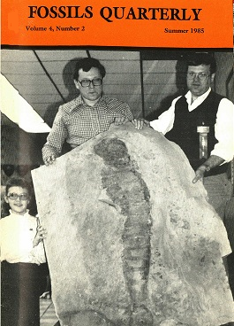

- 1971 World Tiara and Moon Rocks
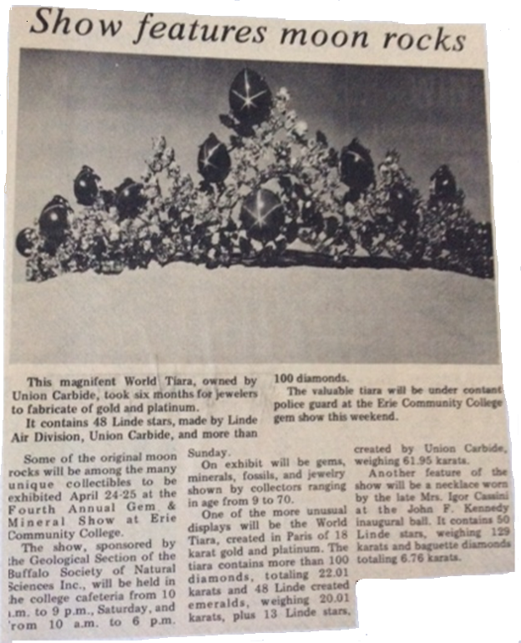
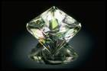
  - 1994: A large Faceted Calcite Crystal owned by club members Harold and Doris Dibble that was on its way to exhibition at the Smithsonian Institute in Washington DC, where it is currently part of their permanent collection. The 1,865 carat crystal was faceted by Art Grant.

  - 2004: A large Mastodon Tusk and molar collected on the Buffalo Museum of Science field expedition in Byron NY. The specimens are part of the permanent collections of the Museum. For the second time in our history, a sample Moon Rock, on loan from the New York State Museum was also displayed at the 2004 show.
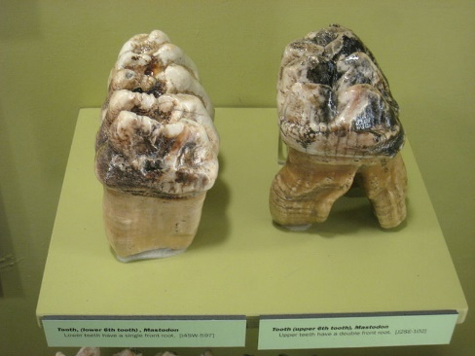
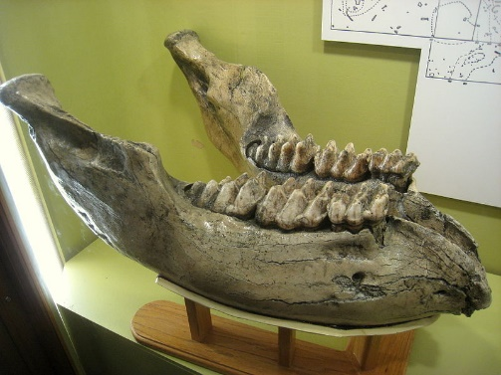

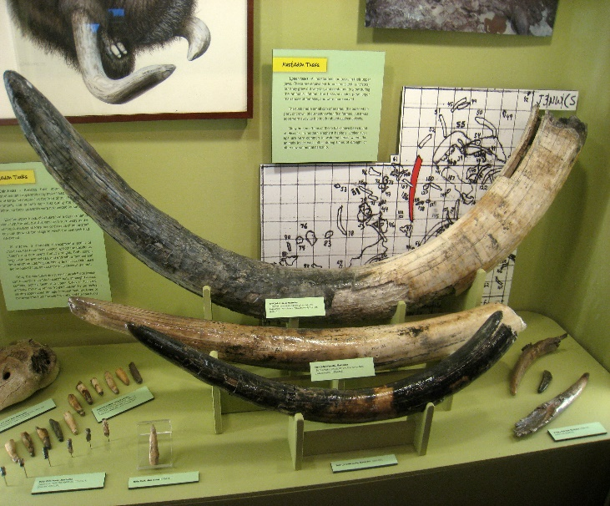

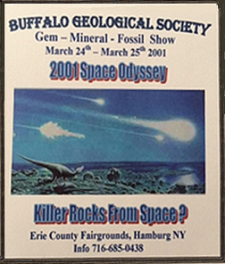

  - 2001: Specimens from the 8th largest private collection of meteorites in the world, owned by club member Scott McKenzie.

  - 2012: John Spina Fossil Exhibit including 12 cases of: Arthropods, Trilobites, Fish, Corals, Stromatolites, Plants, Brachiopods, Mollusks and Echinoderms.
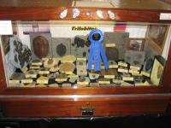

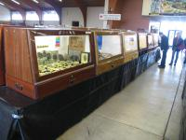
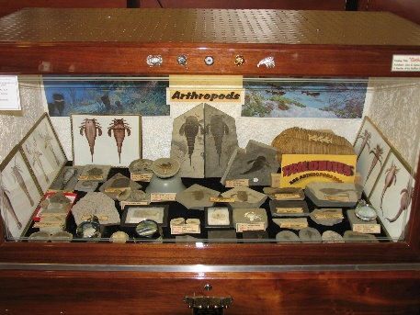

MINI MINE
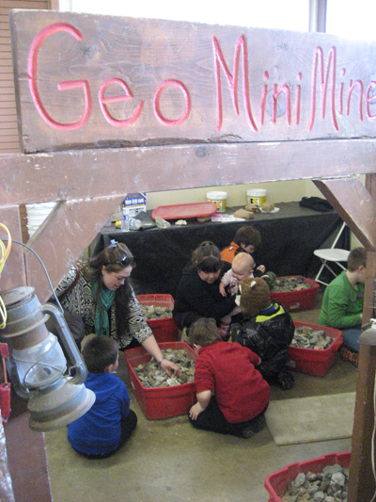
  - The structure housing the famous children’s attraction first appeared at the 1976 show. The paper mache was designed and built by club members Jim and Cindy Ahl.

  - An average of 35 to 40 buckets of Mini Mine rock are given away at each show.

  - A record 2800 plus pounds of rock were mined by 850 young miners at the 1990 show.

  - The 1992 show hosted a record 982 miners.

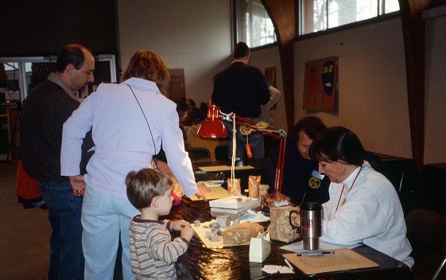

Patricia Giordano-Birtz and Steve Birtz identify a young miner’s finds outside the Mini Mine

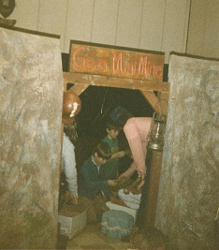

A view from the mine entrance, beyond which NO parents are allowed!

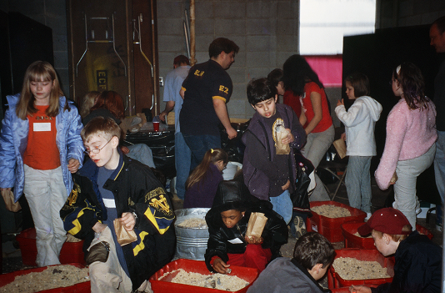

Young miners seek hidden treasures in the saw dust

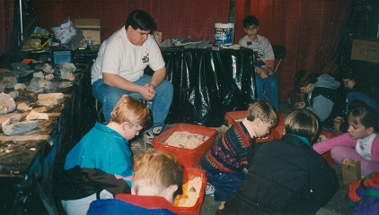

Jason Birtz overseeing the young miners

GRANDPA’S CORNER
Started in 2006 by Dale and Judy Russell, Gandpa’s Corner has over the years entertained thousands of youngster by appealing to their creative side. In addition to coloring pictures of dinosaurs and eurypterids, children were instructed in making beautiful bottle art using colored salt and baby food jars. In 2007 alone over 100 pounds of salt was used to create over 225 sculptures. Unfortunately time and the food industry’s move to plastic jars brought an end the popular event in 2017.

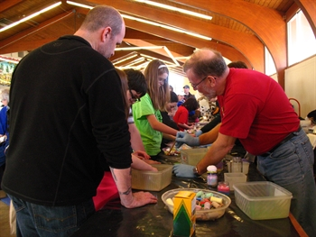
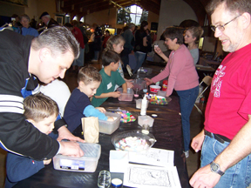

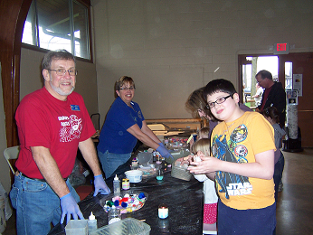

DEMONSTRATORS
Soapstone Carving, Sphere Making, Fossil Preparation, Jewelry Making, Glass Bead Making, Flint Knapping, and Cabochon Making and numerous other crafts have all been demonstrated by Club members at our Show over the years.
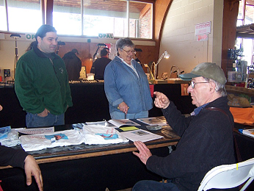

Demonstrator Chair Ruth Banick with Demonstrators Joe LaRussa and Sam Ciurca

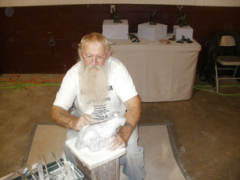

Sandy Cline – World renowned carver Sandy Cline has fascinated our guests for several years. His work is in collections around the world, including that of Prince Phillip. His sculptures were even used by Sports Canada as presentations during the 1988 Winter Olympics.

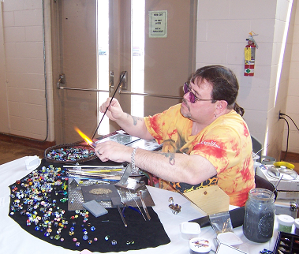
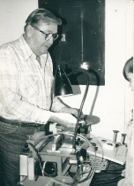

Jim Redden - Glass Beading

Jim Dee using a flat lap to polish stones

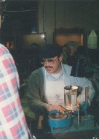
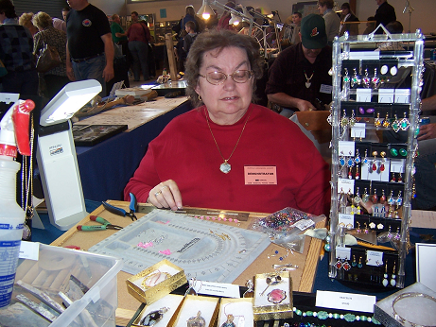

Marilyn Broad – Jewelry Making
Flat lap demonstration

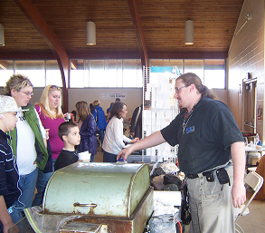
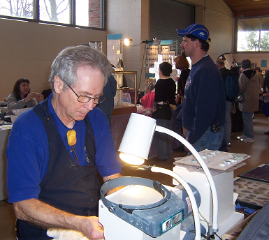

William Broad - Cabachon Creation Seth Bruckheimer - Rock Cutting
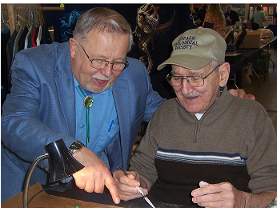

Bruce Banick shares some Soapstone Carving secrets with Show Chair Bob Hoffman
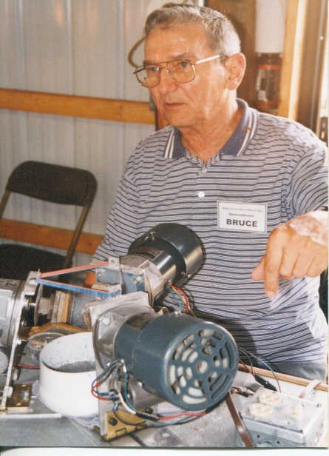
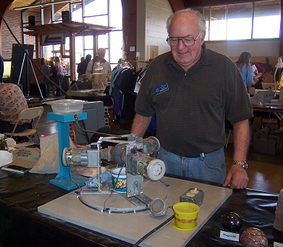

Alvin Andrzejewski and Bruce Banick explain the workings of their Sphere Making machines

MEMBER EXHIBITS
Over the years the Show has served as a forum for members to showcase their private collections. Often referred to as an “Instant Museum”, at times over 30 cases, including some nationally recognized, award winning material, have been on display at our Show. Spanning the spectrum of geologic categories from fossils, and minerals to the lapidary arts below is just a sampling of some of the cases that has been on display in the past.
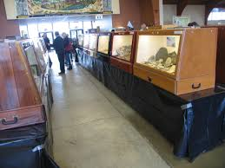

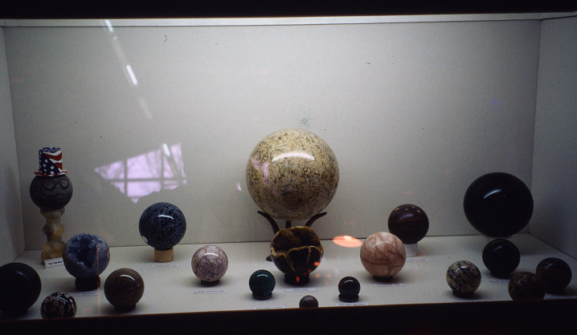

Bruce Banick’s SELF MADE Spheres

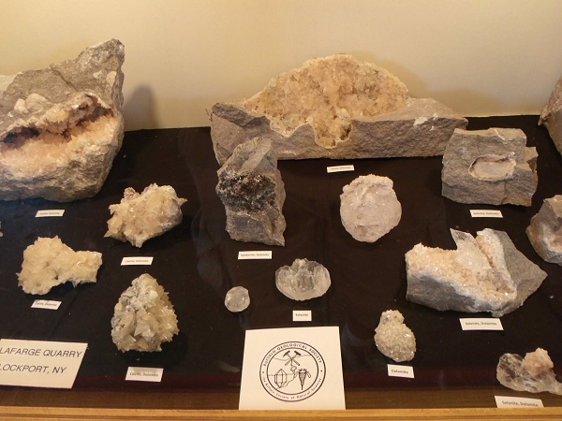

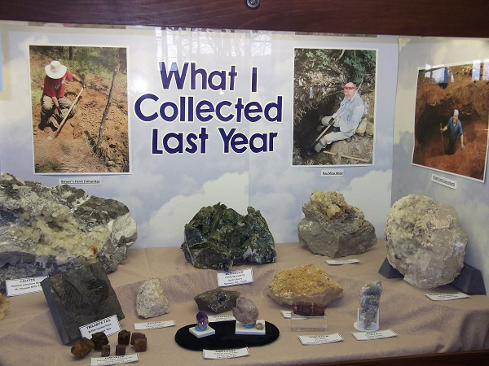

Dale Russell’s treasure troves from BGS field trips are always a big hit

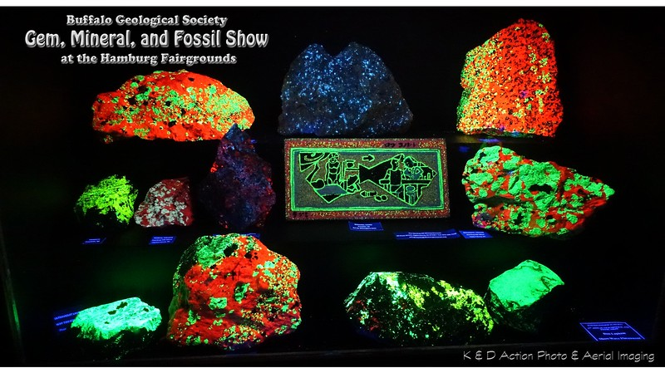

Gerry Wochadlo and Don Lapham III mystify visitors each year with their outstanding Fluorescences
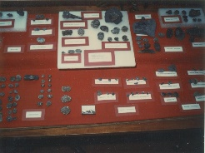

Local Pyritized Fossils – Rosa Long

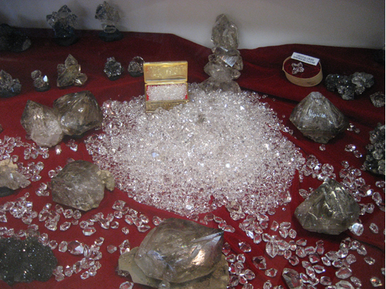

Dazzling Herkimer Diamonds - Art Werner

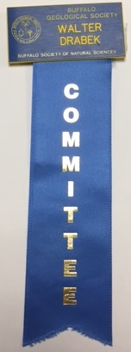
TRIVIA
  - Dealers from all over the United States and Canada participate at the show each year. Starting with under 10 dealers in the early years the number grew to over 30 by 2008.

  - Attendance rose from an average of 1500 in the early 70’s to over 4200 by 1993, an all-time high.

- The first show with an advertising theme was in 1971, which was marketed as “Rocks through Time and Space”.

  - As an advertising promotion in 1978 the club purchased a t-shirt with a eurypterid printed on it. The t-shirt was presented to local TV personality Barry Lillis, who wore the shirt on one of his TV appearances.

  - In 1976 the club purchased advertising in the Buffalo Evening News. The advertisement was accurately printed, but appeared in the obituary section. A newsletter snippet wittily addressed the issue:
“Persons may have wondered, when they saw the publicity for the Spring Show at the Morin Post in the Buffalo Evening News. We do collect fossils but why did the item appear on the Obituary page?”

April 1976 GEOLETTER

- 1974 saw the each visitor receive 2 sheets of origami cutouts that could be folded into 3 dimensional crystal forms. Each of the 6 basic crystal systems were represented in the handout.

  - The 1973 showed actually had its own theme song, sung to the music of “Rock a Bye Baby”
“ALL THAT GLITTERS”
Rock a bye fossil, in a box,
Over the years you turned to rocks,
When with my hammer,
I struck a blow,
Picked up and took you to put in the show.

Rock a bye mineral shiny and bright,
Oh how you glisten in the light,
My hammer, struck chisel
Placed on the rock face
Took crystals and matrix to grace my showcase

April 1973 GEOLETTER

  - The Gemini Gem & Mineral Club of Burlington Ontario, rolled the “International Rolling Rock” across the border to our club during our 1982 show. After adding our name to the plaque, it was rolled back the next year to another Canadian club to encourage and promote fellowship among the rock hounds of Canada and the US. On March 18, 1983 the Rolling Rock was presented by President Joe Butch to the Niagara Peninsula Geological Society at Brock University in St. Catherines Ontario.
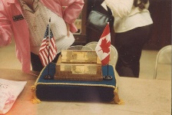

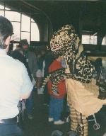

  - 1993 showcased Dr. Donald Birdd of Buffalo State College mingling with the attendees in a life size Deinonychus costume.

SHOW PARTNERS
Over the years numerous outside organization (mostly non-profit) have contributed to the quality of our Show. These include The Hamburg Natural History Society, Department of Environmental Conservation, NY State Parks, NY State Museum and local College Geology Clubs. All have been provided with free space to promote their organization.

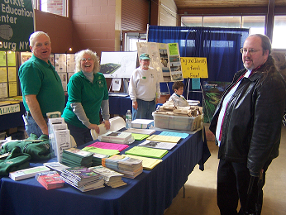

New York State Parks Educational Exhibit
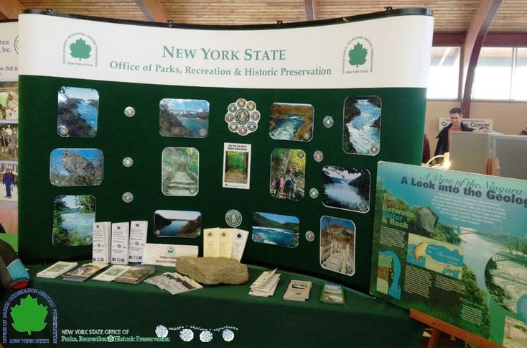

Jerry Bastedo representing The Hamburg Natural History Society

  - One local Mineral and Fossil dealer – Glen LaPlaca owner of Past & Present Rock Shop has been particularly prominent when it comes to augmenting our exhibits. Glen has supported our Show annually since the opening of his shop by not only purchasing table space but by bringing some spectacular exhibits appealing to both young and old.
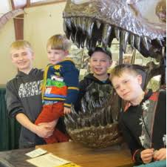
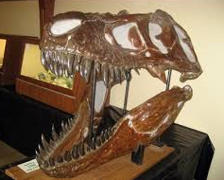

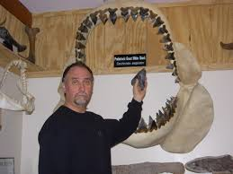

ADVERTISING
Television, Radio, Newspapers, Posters and Flyers have all been used over the years to increase show attendance. But by far the most effective media has proven to be a simple reminder post card. Guests sign up at the admissions table and their reminder for next year is sent on its way four weeks before the show. This year over 2,500 cards were mailed out in early March.
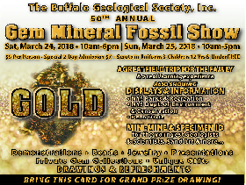
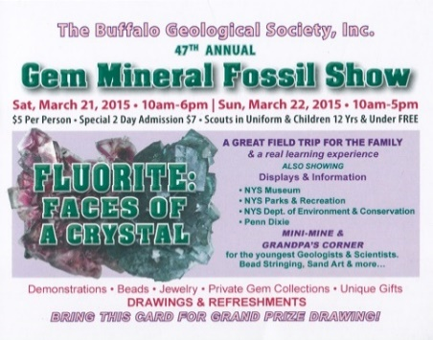
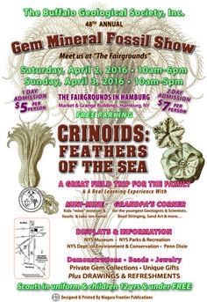
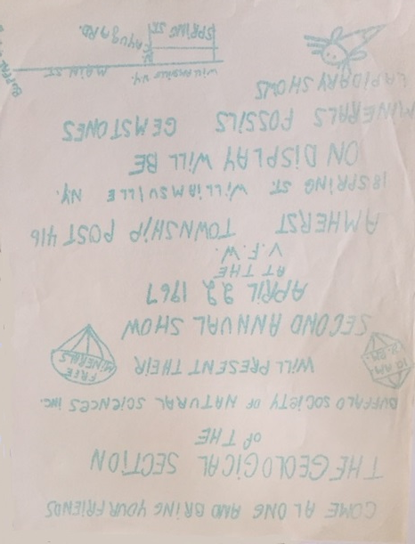
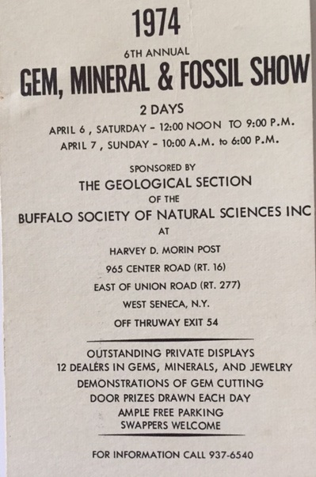
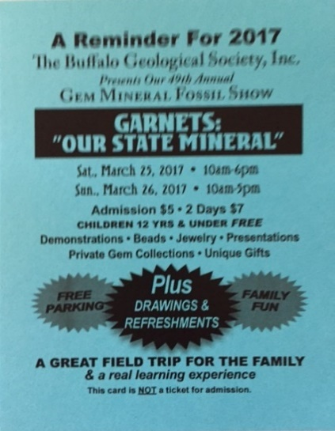
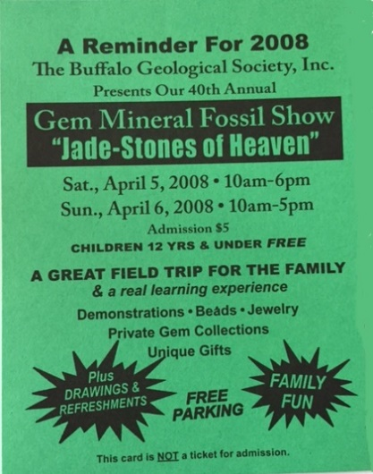
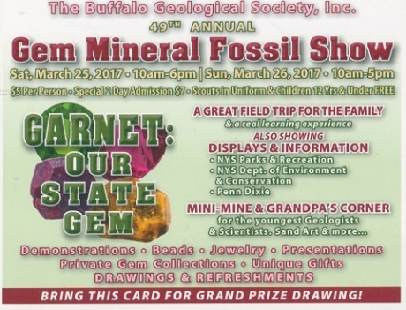
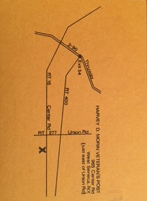
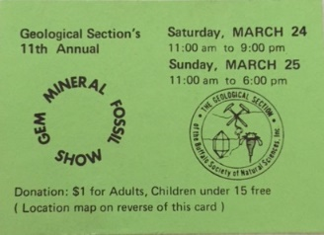
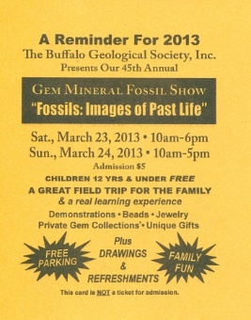
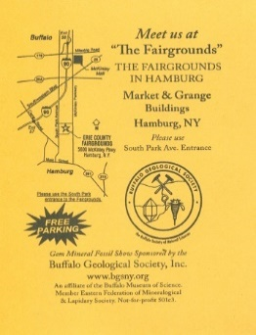
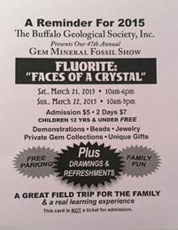
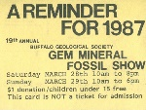
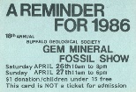

Over the years numerous prominent experts and researchers have spoken to our membership. Topics have ranged from Spelunking to the Geology of Mars. But, by far the most frequent topic was focused on fluorescence.

- The most frequent speaker by far was our own Dr. Henry E. Stadlinger DDS whose first presentation was in 1957. Since then he educated and fascinated our members over 20 times, speaking regularly through the 1990’s. Most noted for his fantastic photography of minerals, his topics included, crystal features, pseudo morphs and inclusions in minerals. But, in keeping with the trend his most common topic was fluorescence.
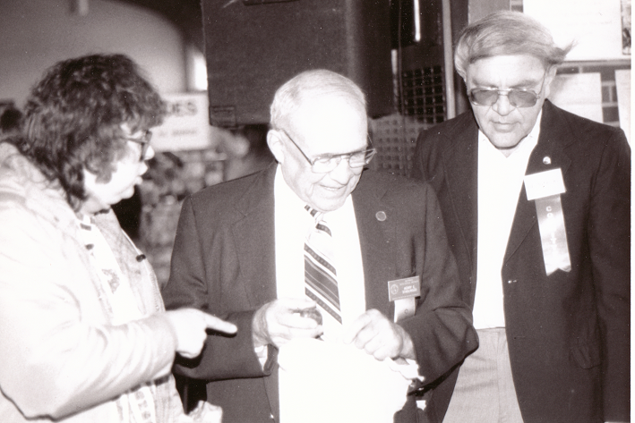

Dr. Henry Stadlinger (Popular Speaker and long-time Board Member) and Edward Rutecki (Past President and Life Fellow of the Buffalo Society of Natural Sciences) discuss a specimen with a Show visitor.

- Occasionally, a speaker draws a crowd of overwhelming proportions.
  - One such event occurred on November 1, 1963. On that date, Dr. Victor Meens of the Royal Ontario Museum spoke on “Burma – Land of Ruby and Jade”. For the first time we were forced out of our normal meeting space in the Humboldt room and into the auditorium. Those 100 people just wouldn't fit.

  - In 1985 Hedy “The Dinosaur Lady” Hobberlin of Toronto, Ontario spoke to 150 people including over 60 children. A record crowd that stands to this day.
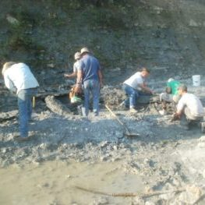
IN THE FIELD

- In addition to most of the local creeks and quarry the club has collected in quarries throughout the eastern US and Canada. Canadian localities have included Bancroft, Beamsville, Dundas, Flamboro, and Fort Erie Ontario, while sites outside of New York State have been as far away as Cincinnati, Paulding, and Sylvania Ohio.

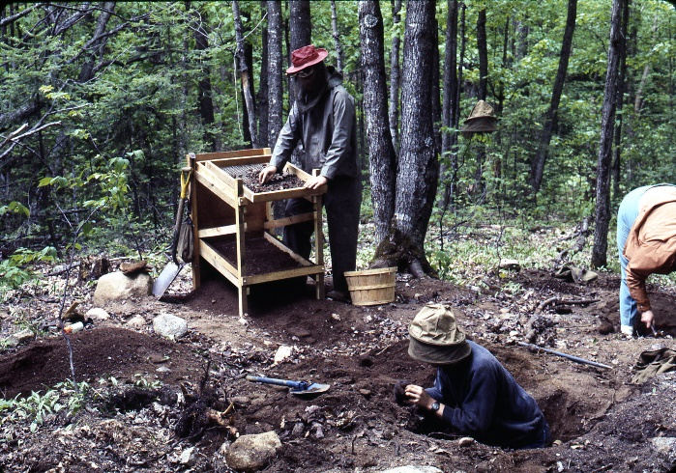
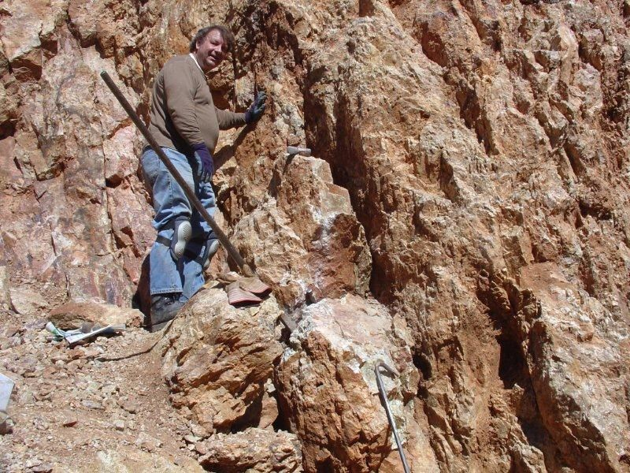

- Two of the most popular sites Niagara Stone Quarry and LaFarge Quarry in Lockport have been visited regularly since the 1950’s.
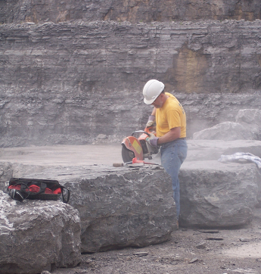
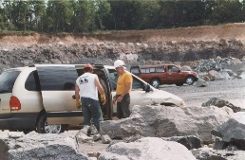

Brothers Dave and Dale Russell strategize before attacking a rock.
Dale Russell uses a rock saw to extract his find.
- In 1955, club members were permitted access to the rock dumps of the Sir Adam Beck Power Project at Niagara Falls Ontario. Many excellent fluorites and calcites were collected, some donated and still housed in the collection of the Buffalo Museum of Science.

- With the incorporation of the Geological Section as a legal entity in 1960, many of obstacles created in the mid 50’s to running field trips were now removed. On August 14 of that year, section members participated in the first field trip to be held in several years. Twenty-seven cars with 50 members and guests descended on the Crushed and Cut Stone quarry, in Dundas Ontario and came home with some beautiful specimens of Celestite, Sphalerite and Calcite.
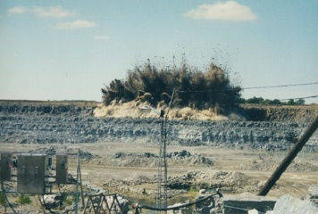

- In 2000 our club visited the LaFarge Quarry in Paulding Ohio, where members witnessed a live blast of the quarry wall.

- Trips to Herkimer New York were popular in the 1960’s and 1970’s to collect the world famous “Herkimer Diamonds” In 1971 a bus trip cost a member only $10.00. A side trip to Passage Gulf for eurypterids was also sometimes part of the adventure.
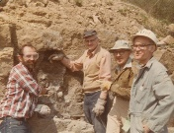
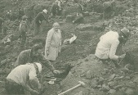

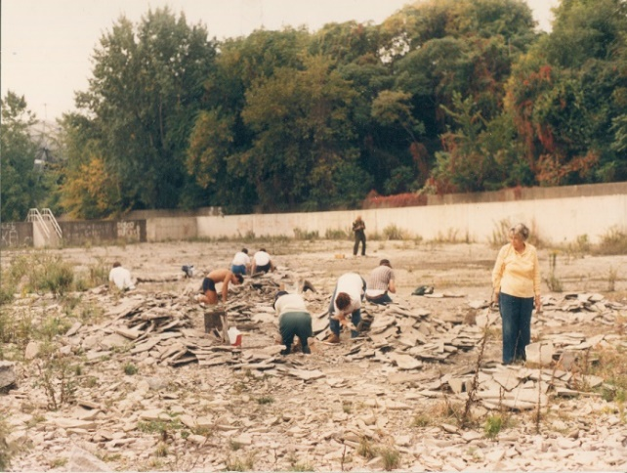
- Up through the early 1990’s Club trips to the famous Bennett Quarry were still being held. Home to many of the earliest found Eurypterids in the Museum’s collection, trips here continued despite its conversion to a city storm sewer overflow holding chamber.

- Local Fossil sites are visited annually by ardent collectors.
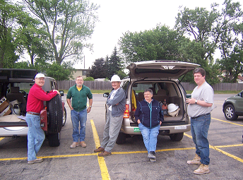

Members, Don Lapham III, Dale Russell, Bruce Banick, Ruth Banick and Joe Sullivan gather to enter fossil quarry in Cheektowaga.

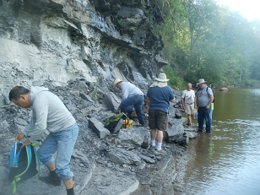

Club members examine outcrop on 18 Mile Creek.

- Family Friendly trips are a big part of the BGS collecting itinerary
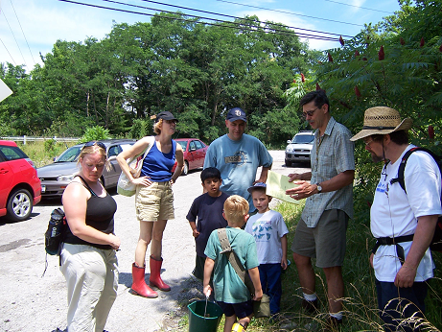

A trip to Buffalo Creek led by Elise and Jon Nickerson.

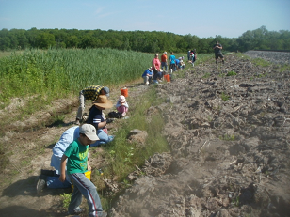

Jerry Bastedo arranged this trip to “The Gulf” in Lockport for Silurian Fossils.

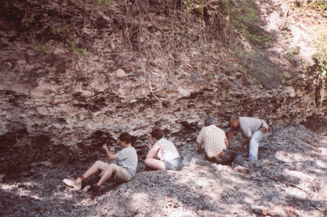

Bob Hoffman guides families on a trip to Spring Creek in Alden.

- The BGS Takes on a Wall !

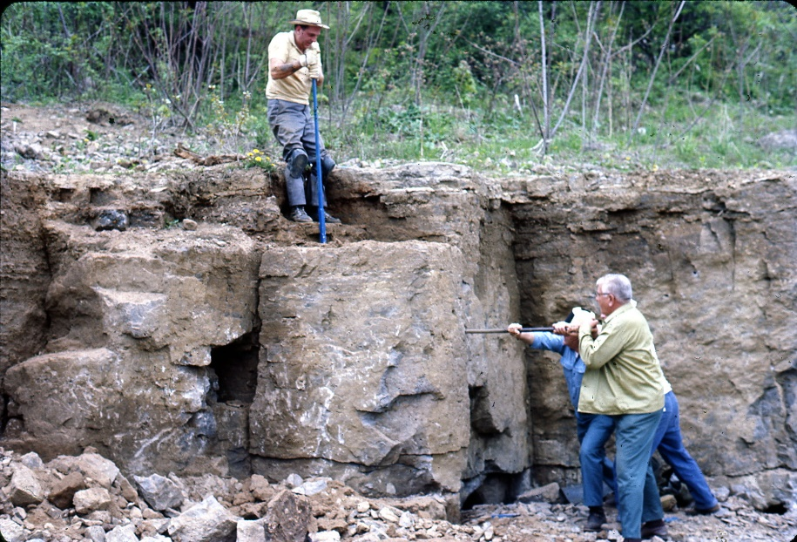

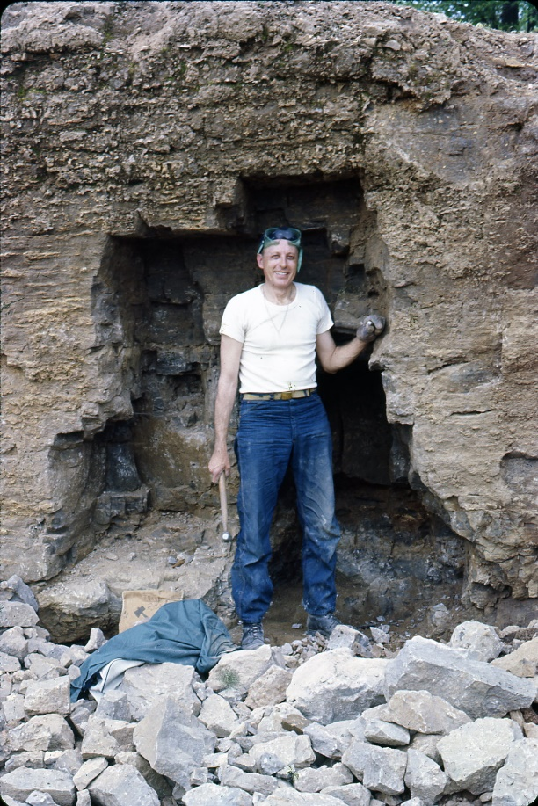
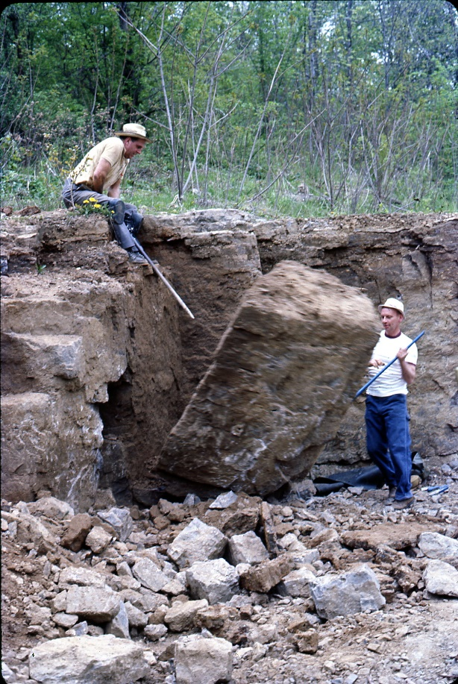

Joe Urbanick, Marv Hess and friends attack a wall in Middleville, NY in 1969

BUS TRIPS
For those seeking a less muddy experience, bus trips to several renowned natural history museums were also on tap for our membership including the Royal Ontario Museum, Smithsonian, American Museum of Natural History and more.

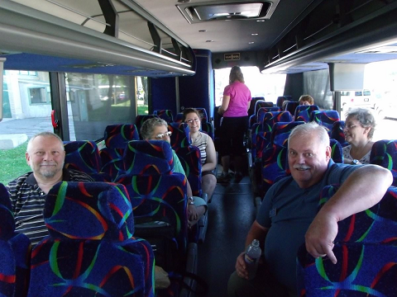

A bus is loaded and ready to roll, with Joe Butch and George Schwartzgott at the front.

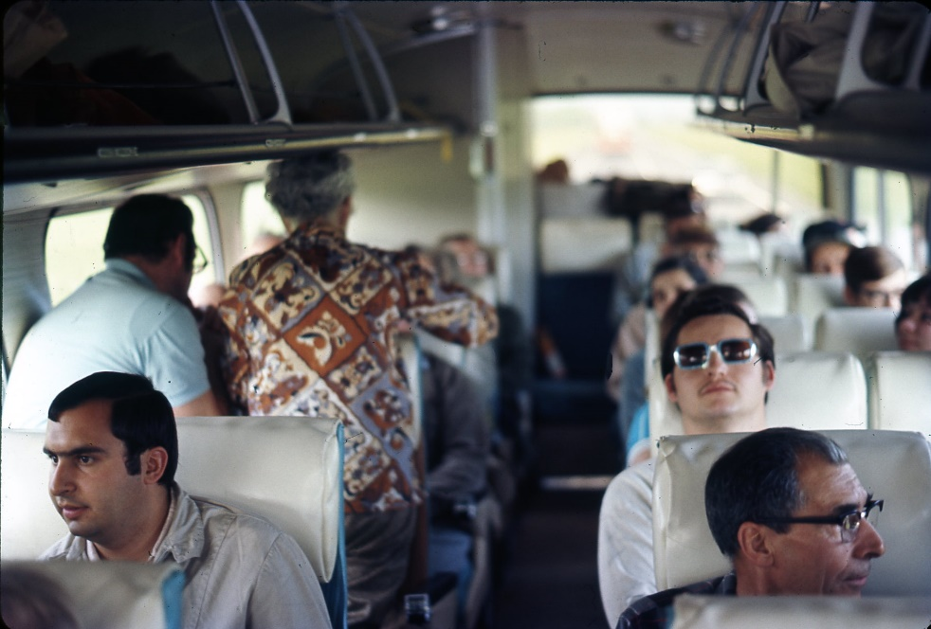

Neither the comfort nor the enthusiasm seem to have changed much since this trip to Herkimer in 1969.

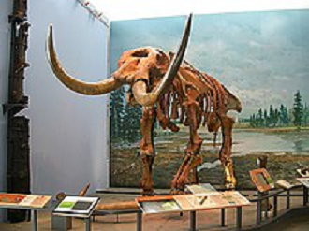

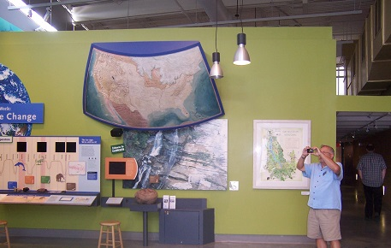

Bob Hoffman bringing home views from the Paleontological Research Institute

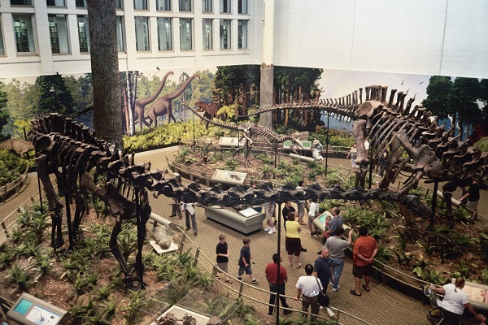

Our members roam among the Dinosaurs at the Cleveland Museum of Natural History

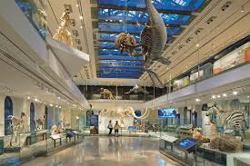

The Carnegie Museum in Pittsburgh has been a frequent stop for our members.

UNIQUE ADVENTURES

- Canisius College Seismograph station in 1963.
- In October 2001 the club took a boat trip through the Lockport Locks.
- AFMS/EFMLS Rock Show hosted by the Syracuse club in 2011.

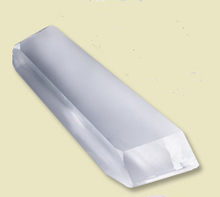
- Sawyer Research Labs, an industry leader in the hydrothermal growth of quartz crystal for over 60 years, opened its doors to the BGS in 1996. Club members were able to take home samples of large cultured quartz crystals a once in a lifetime opportunity.
Image from Sawyerllc.com

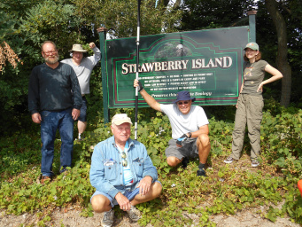
- Fall of 2017 saw a group led by Paul Leuchner kayaking the Niagara River in search of the fossils of Strawberry Island.
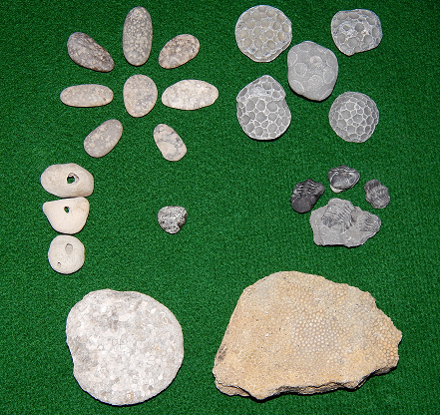

- Starting in 1954 and continuing annually through the mid 1970’s Ward’s Natural Science Establishment in Rochester NY opened its doors to our members. Minerals were displayed on open tables and in countless drawers and bins. Members needed to simply take a tray walk around, fill it with goodies and oh yes, remember to check out (at a nice discount) before leaving.

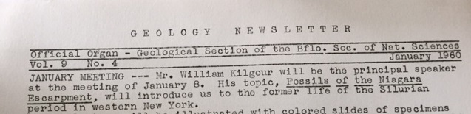

- Our present day newsletter received its name in 1974, when motion was made by Girt Hird at the February meeting to rename the newsletter to “GEOLETTER”. Evelyn Ullrich submitted the winning entry, beating out 31 other contestants. The name first appeared on the February 1974 issue.
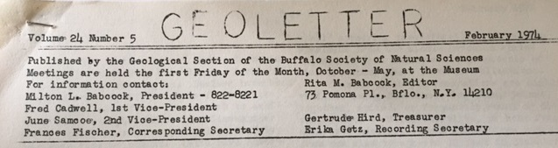

- After trying different mastheads to partner with the new name, the Board finally settled on what ended up being our current masthead (EMBLEM SERVING AS “O” in name). The design by a member of the Museum’s Preparation department, Dale Ransom, was first used on the June 1976 newsletter.
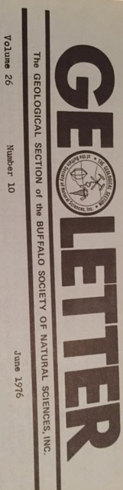

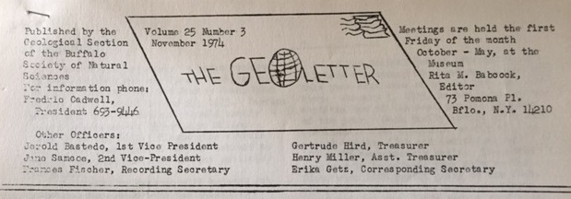

- It was actually a spinoff of an earlier version used by Editor Rita Babcock.

- Club officers originally communicated with members via postcards, to announce upcoming events and information. It wasn’t until 1951 that the first official newsletter was released. Prior to 1955 the newsletter was printed on 5½ x 11 inch paper, and it wasn’t until August 1963 that a multipage letter was produced.

- Over the years Featured columns included:
- The Rock Vignette that ran regularly throughout the 1970’s addressing such diverse topics as “How to Read a Topo Map”, Minerals and Gems of Christmas, How to set up a display case and “Crystal Growing”.
- Science for Rockhounds first appeared November 1977 and ran through May 1989. The highly awarded series at both the national and regional level written by Fred Sievenpiper was the longest running article in our newsletter’s history.

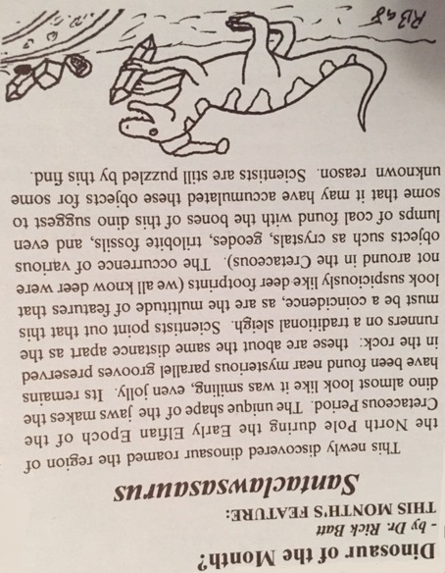

- Dino of the month ran from April 1990 through September 1995. It returned in September 1997 and continued through January 1999. Featuring the artistry of local Dinosaur expert Dr. Richard Batt the series won accolades both for its drawings and dinosaur facts and figures.

- Tales from the Talus written by long time club member Marvin Hess ran from 2003 through 2007. Stories, adventures, quips, tips and lessons learned over 40 years of mineral collecting were shared with ardent readers.

- The Travelling Mineralogist ran from December 1991 through March 1995 and represented an informative and fun travel log of club member and professional geologist Jon Nickerson.

- BGS SPOTLIGHT started by Editor Ruth Banick ran during the 2000 through 2002 seasons. The articles highlighted the careers and interests of Club members and Officers.

- Fun snippets, jokes, poems, quizzes and even recipes have appeared over the years. Some of our favorites:
“Rocky says:
Be gneiss but don’t be taken for granite”

November 1988
“G.E.s laboratory has succeeded in making diamonds from peanut butter. The catch, it costs $3,000 to produce a gem worth $300.”

January 1976
“In 1881, an oil test near Franklin Pennsylvania struck a gusher but it was not oil. It became the nation’s first beer well, having struck Grossman’s brewery storage tank.”

January 1975
“One last thing, hunters killed a bear in Upper Canada. One of its claws was split and in it was a gold nugget. Gold is where you find it.”

Tales from the Talus February 2004

“A Rockhound’s Home
Rocks on the lawn, rock in the sheds;
Shovels and hammers under the bed.
Boots and knapsacks beside the door;
Clay and grit all over the floor.
Slabs and specimens on the chairs;
Boxes of crystals on the stairs.
A Rockhound’s home is a disgrace………….
But oh!
It’s such a happy place.”

January 1982

“One time, years ago, I went into the Dundas quarry all by myself as I had done many times before. I rested for some water and was leaning against the huge shovel not in use. As I gazed across the quarry, the floor of the quarry started heaving up about four feet in a straight line and it seemed to be heading for me. They were blasting and did not know I was there. As it turned out the quarry floor was relieved of its weight and was expanding to relieve rock tension. Sure had me trembling – something I will never forget!”

Tales from the Talus November 2004

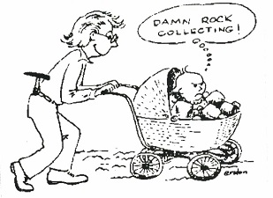
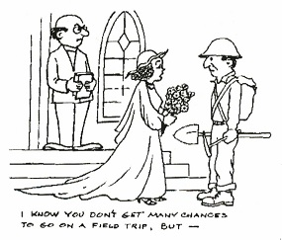

May 2004 Geoletter October 2004 Geoletter
Reprinted with permission of: Erston Barnhart, Central PA Rock & Mineral Club

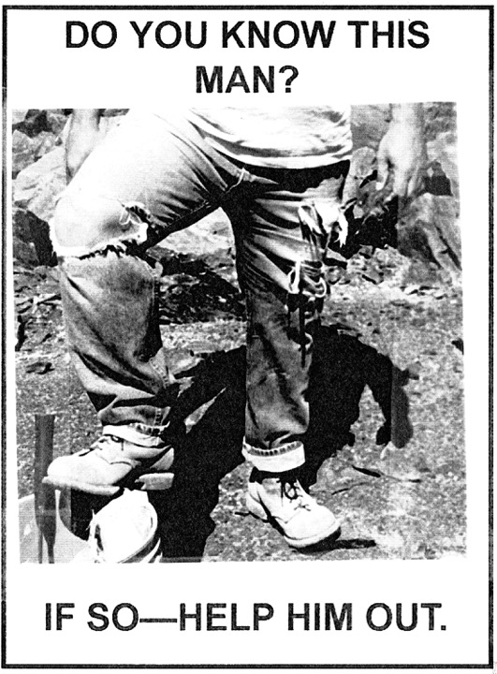

This photo appeared in the February 2002 GEOLETTER’s “Fashion Section”, revealing what was chic in the way of field attire that year.

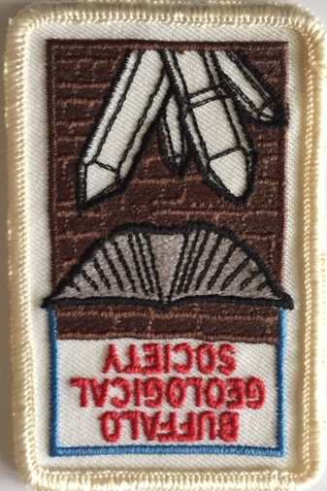

- When members clamored for a new rock hound patch a contest was run by the GEOLETTER in 1988. The contest was won by Steve Condon and can still be purchased today at any club meeting.

- Through-out the years our newsletter has won many First and Second Place awards from both the AFMS and EFMLS. These include top newsletter in the small bulletin class, Best New Editor and Best Series. The highest honor may have come in the 1990-1991 season when the GEOLETTER was permanently added to the AFMS Public Relations Honor Roll housed in the Crater Rock Museum in Oregon.

- In an attempt to be environmentally friendly the GEOLETTER began using Recycled Paper in November 1992.

- The Board approved the sale of Classified ads starting in May 1996. With the first advertiser being Past & Present Rock Shop owned by club member Glen LaPlaca.

- In years prior to 1972 the responsibility of producing our newsletter fell to the club Secretary. But in January 1972, the arduous task became the responsibility of an “Editor”. Rita Babcock was the first to hold the role serving from January 1972 through August 1976.

- Subsequently a number of members have held the responsibility on a short term basis. These included: Frances Hunt, Jerry Bastedo, Rosa Long, Joan Corte, Sherry Batzer, Ron Schmidt, Steve Condon, Ruth Banick and Walter Drabek.

- From September 2003 and continuing through today Marilyn Broad has laudably served as the longest tenured newsletter editor in Club history. Challenged only by Dr. Rick Batt who served from June 1991 to January 1996 and again from September 1997 through May 2000. That’s a lot of newsletters between those 2 club stalwarts.

PICNIC
- The first annual club picnic was an evening event held on August 21, 1974 at the county park at Elma Meadows. It continued there through 2014 with the exception of 1977 when it was held at Ellicott Creek Park in Amherst.

- Starting in August 2015 the event was moved to the North Forest Park, in Williamsville.

- While swapping tall tales and specimens are popular activities at the picnic the main event remains the “cookout”. The pass a dish style dinner is supplemented by club provided soft drinks, corn, hot dogs and hamburgers. You don’t have to be a geologist to love this experience.

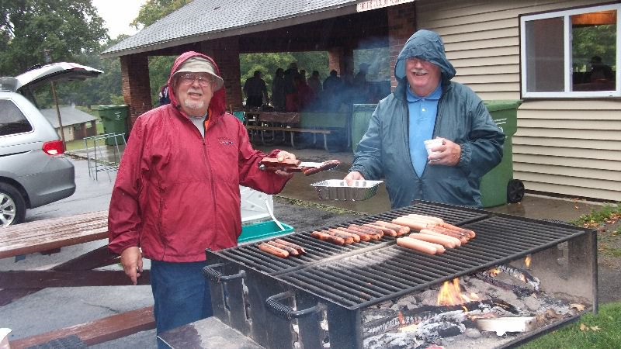

Bob Hoffman and George Schwartzgott see that there are Hot Dogs for everyone

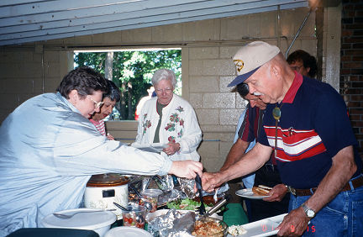

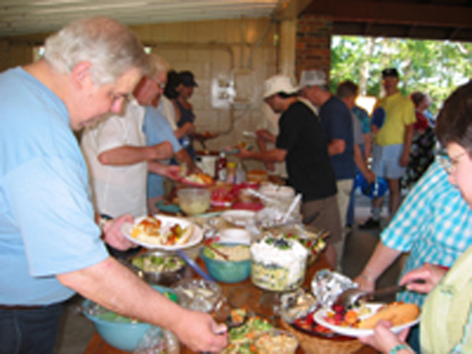
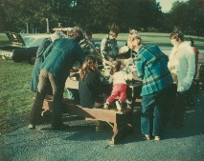

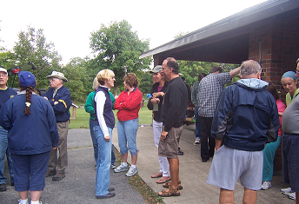

Banquet
- The first official club banquet was held on December 4, 1958 at the American Legion 40&8 club on Delaware Avenue. The steak dinner cost only $3.25 and over 50 members and guests attended. The keynote speaker was David E. Jensen who spoke on “Mineral Structures” and the table favors were vials of zircon sand from Florida donated by Charles Jacobs.

- Since that time the annual event, now held in May has moved around to make it convenient for members from all parts of town.
  - Southtowns: Romanello’s, Lakeview Hotel, LaGalleria
  - Northtowns: Little White House, Holiday Inn Amherst, Mindy’s WineCellar, Carriage House, Classics V
  - City & Eastern Suburbs: Parklane, Royal Knight, Candlelight Room, Salvatore’s Italian Gardens, Depew Grove, Protocol
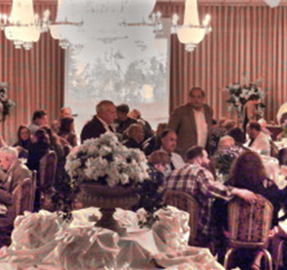
- The Board has voted to subsidize the Banquet going as far back as the 1960’s. In 1970 for example the Club contribution was almost 25%, charging members only $5.00 for a $6.60 meal. Although the amount of the subsidy has varied over time, the tradition has continued unbroken through today, with members always getting a great deal.
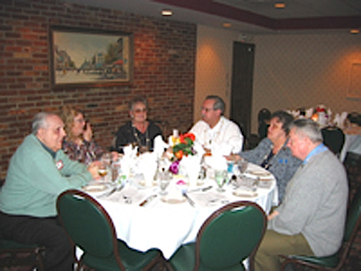
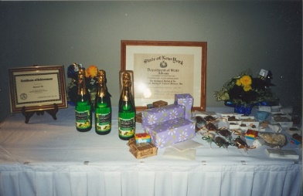

Auctions
- The club has held annual auctions almost since its inception. Over the years several specimens have exchanged hands with values ranging from ten cents to hundreds of dollars. Special children only items are auctioned to give everyone a chance to acquire a prize specimen. In addition to a standard interactive auction, the December Holiday dinner is usually combined with a silent auction, where members can bring home inexpensive stocking stuffers to complete their Holiday shopping lists.
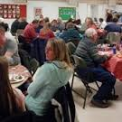
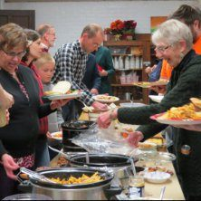

The Holiday Pot Luck Cuisine always Plentiful and DELICIOUS !

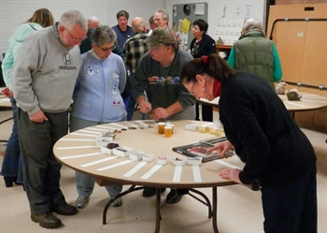
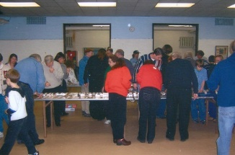

The Competition for for prized specimens at the Silent Auction is can be quite intense.
50th Anniversary
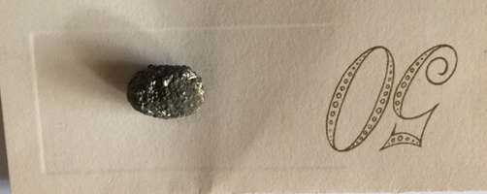
On May 7, 1988, 56 members and guests gathered at the Parklane Restaurant on Delaware Avenue. Dr. Irving H. Tesmer spoke on the “Our Western New York Geological Heritage”. Distributed as favors were pyrite nodules from Alden NY attached to an anniversary card along with a gold colored souvenir program summarizing the Club’s history. The synopsis was written by long time member Steve Birtz.

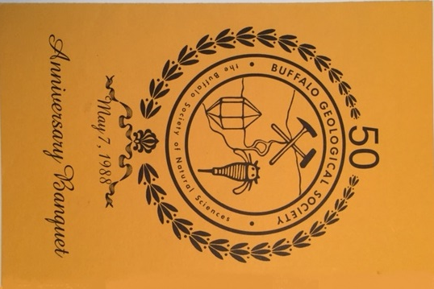

Our organization has always sought to play a role in science education. As such we have been significant participants in:

  - Earth Science Day at Penn-Dixie
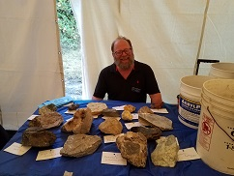
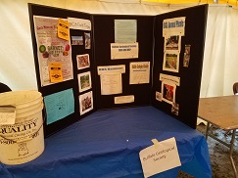

  - Reinstein Woods Nature Preserve festival
  - LaFarge Quarries Community Day

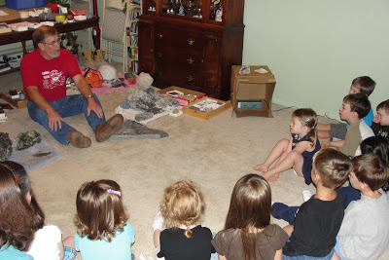

  - Classroom Visits

Dale Russell captivates a Home School Class
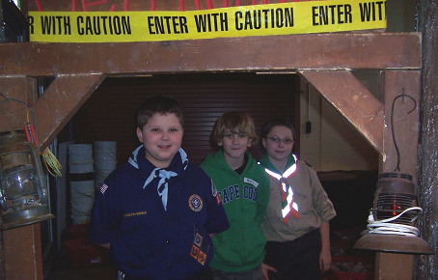

  - Boy/Girl Scout Merit Badge classes

  - Buffalo Museum of Science Events:
    - Museum Good Earth Festival started 1979
    - Dinosaurs Alive 1988
    - Dino Daze 2016 and 2017
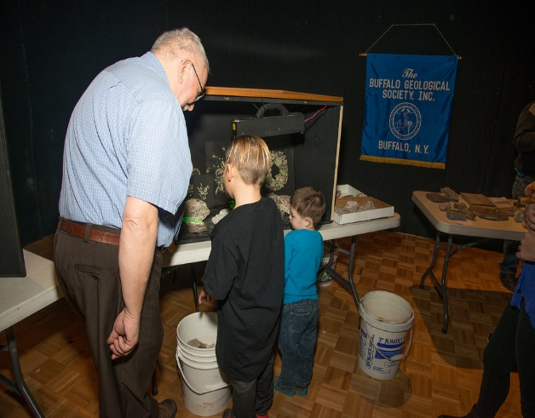
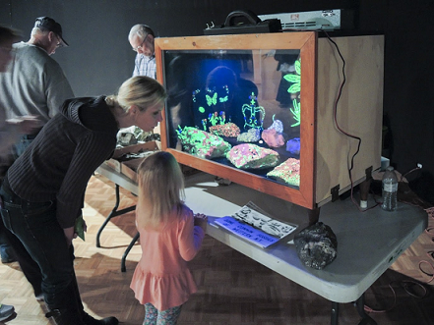

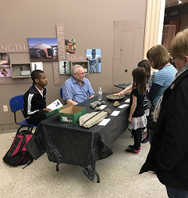

- Explore Science Earth
& Space 2017

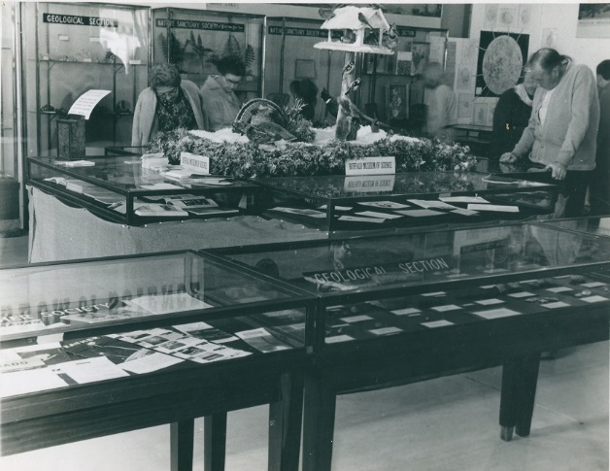
    - Spring Geology Exhibition Event between 1970 and 1985. Members, annually supplied as many as 15 cases of rocks, minerals and fossils for public exhibition, while the Museum supplied the cases, labels and insurance.

- Not only have our members been generous with their time but also with their money as our club has donated generously to the Buffalo Museum of Science for:
  - Radiocarbon dating of Byron Specimens
  - Junior Education program
  - Magazine subscriptions
  - Renovation Fund
  - Annual Fund
  - Mineral acquisition
  - Acquisition of a life size replica of the dinosaur Deinonychus

Most of this funding has come from the liberal sharing of Gem Show admissions and Mini-Mine proceeds.

In March 1984 the Museum opened its new Mineral Hall. The BGS not only hosted the opening event but Club member Clyde Alday provided the first rotating exhibit displayed in the Hall.

2005 saw the Club again support a Museum exhibit. This time a substantial donation was made to create a Eurypterid exhibit in the main floor of the Museum.
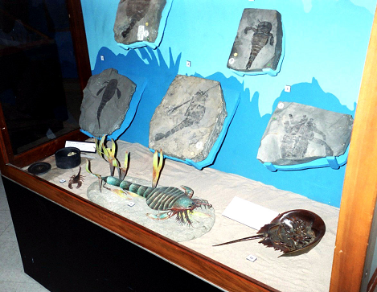

- In addition to providing assistance to the Museum, funds have also been directed in support of:
- The Franklin Mineral Museum
- Braun-Ruddick Seismograph station
- WNY Science Congress
- Cradle Beach
- New York State Geological Association
- Hamburg Natural History Society building fund
- St Mary’s School for the Deaf
- The publication of: “The Geology of Cattaraugus County” by Irving H. Tesmer

- In 2000 the Board voted to support scholastic achievement more directly by establishing a BGS Scholarship in October of that year. The program, championed by President Lois Shriver used seed money from the Club’s General fund and sought to supplement this with donations from outside groups as well as by monies raised by various club events.
- The first scholarships were awarded to active junior members Sam Sly in 2001 and Dawn Rutecki in 2002.
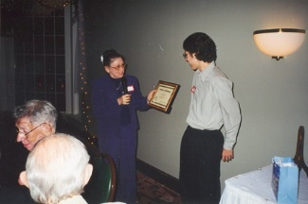

- In November 2009, the estate of long time club member Marvin Hess auctioned his collection, donating the proceeds to the Scholarship fund. The sale of over 400 lots raised in excess of $7000.00 during the day-long event.
- Over the years several donations were made to the fund by club members including the estate of past President and father of our 2002 recipient Edward Rutecki. However, difficulty attracting candidates and external funding sources brought the sustainability of the program into question.
- In 2016 Nathan Mutka received the last award from the fund which was renamed the Robert Hoffman Memorial Education Fund in honor of our late President.
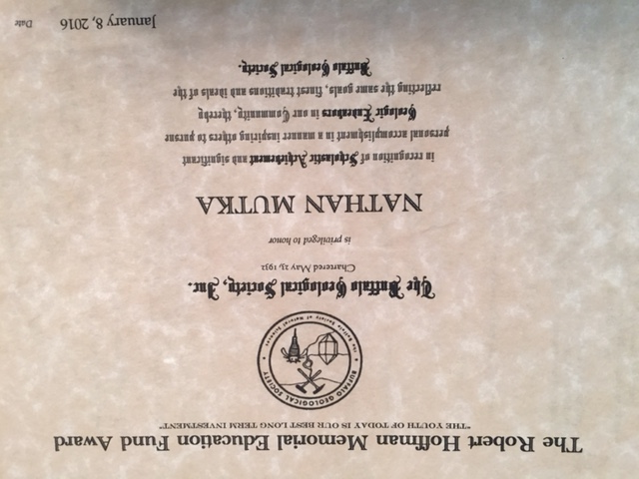

- In 2017 the Board lifted the scholarship only restriction on the fund, to allow school programs, publications and other educational activities to be considered for donation.

- Over the years many of our members have received recognition on both the regional and national level for their contributions to our hobby:
- AFMLS First Place award in the video category for “Soapstone Carving” by Bruce and Ruth Banick. The Banick’s were also acknowledged for several of their newsletter articles and competitive displays.

- Members Anthony Dunn and J. Carl Burke were recognized by Rocks and Mineral Magazine in 1975 with the publication of their article, "A Weekend Mineral Collecting Trip to Ontario"

- Loren Babcock’s Science Congress lecture and display was on exhibit in Hengerer’s downtown store as a part of the store’s “Salute to the Buffalo Public Schools” in 1975. At that time Loren was a junior member of our club.
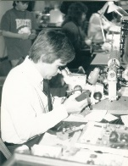
- Longtime member Gerald Kloc has also received national recognition over the years for his outstanding fossil preparation skills. His works can be seen the collections of many major Museums, including the Smithsonian as well as in several professional publications.

- In 1992 John Spina was recognized by the Royal Ontario Museum by being appointed to join a very select group on an expedition to British Columbia to collect the internationally protected Burgess Shale.

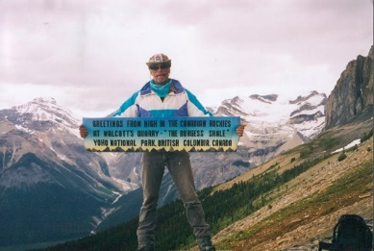

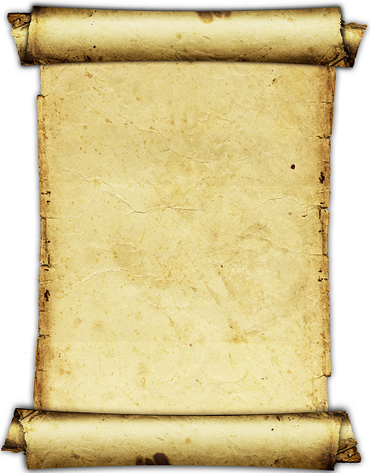

BUFFALO GEOLOGICAL SOCIETY, INC.
REVISED: APRIL 3, 2009
CONSTITUTION

ARTICLE I: NAME
This organization shall be known as the Buffalo Geological Society, Inc. It is an affiliate of the Buffalo Society of Natural Sciences, Inc.

ARTICLE II: HISTORY
A mineral club has existed in one form or another since the inception of the Buffalo Society of Natural Sciences in 1861. The Geological Section of the Buffalo Society of Natural Sciences was started February 2, 1938 and later incorporated on June 27, 1960. The Geological Section changed its name to the Buffalo Geological Society, Inc. on December 14, 1982.

ARTICLE III: PURPOSE
The purpose of this Society shall be to engage in and encourage the study of the Geological Sciences, the Lapidary Arts, the collection of fossils, minerals, and rocks, and to promote, exhibit and sponsor excursions and field trips for the aforementioned purposes.

ARTICLE IV: NONPROFIT STATUS
The Buffalo Geological Society, Inc. is a nonprofit organization. No member of this Society shall have any right or interest in the property or assets of this Society. In the event of the dissolution of this Society, any assets remaining after the satisfaction of all liabilities shall be distributed for charitable or educational means as provided for under Section 1005 of the Not-for-Profit Corporation Law of the State of New York.

ARTICLE V: PARLIAMENTARY AUTHORITY
Robert's Rules of Order shall govern the proceedings of all meetings of this Society unless different provisions are found in these by-laws, in which case such provisions shall prevail.

ARTICLE VI: GOVERNMENT & MANAGEMENT
The government and management of this Society, except as otherwise provided by law or in the By-laws of this Society, shall be vested in the Executive Board of this Society. Any authority of government, management or control not otherwise specified in either the Constitution or By-laws of this Society shall be reserved to the Executive Board, and the Executive Board shall be vested with full power and authority to put in effect the laws, resolutions and decisions of this Society.

By-laws

ARTICLE I: MEMBERSHIP
Membership categories are as follows: Individuals, Student, Family, and Honorary Life.

Individual membership shall consist of any individual person 18 years of age or older.

Family membership shall consist of one or two adults at any one address, who shall be considered regular members with all the rights and privileges of membership, all children under age 18, and children who are students regardless of age.

Student membership shall be those members under 18 years of age, who are not included in a family membership.

An Honorary Life membership may be awarded upon the unanimous vote of those present, of the Executive Board, based on outstanding service to the Buffalo Geological Society. An Honorary Life member, and his or her spouse, shall have all the rights and privileges of regular members, but shall be dues exempt for the life of the honorary member.

A gift membership may be given to any individual at the discretion of the Executive Board.

ARTICLE II: DUES
Annual membership fees shall be due and payable April 30th. These fees may be adjusted by the Executive Board as occasion demands.
Those members in arrears of annual dues shall not be allowed to retain membership in the Society.

ARTICLE III: MEETINGS
Regular meetings of members shall be held on the first Friday of each month from October to April unless the Executive Board changes the date due to holidays or special occasions.

The May meeting shall be a banquet at which new officers shall be installed and services recognized.

The September meeting will be the annual picnic, the time and place to be determined by the Executive Board.

Special meetings may be called at any time by the President or any duly elected Officer or Board member, or upon written request signed by ten or more members. The President or any Officer may preside at a special meeting. A notice shall be conveyed to each member in good standing at least 5 days prior to any special meeting stating the time and place such meeting is to be held.

The Executive Board meeting is usually held the Thursday following the regular monthly meeting.
All meetings are open to the members and all interested parties.

Any person under 18 years of age shall be accompanied by a regular member, parent, guardian or other responsible person over 18 years of age at all Society functions. For field trips at quarries and other special functions all participants shall comply with the rules of the property owner.

ARTICLE IV: QUORUM
To conduct regular Society business at Executive Board meetings, a quorum must be present. A quorum shall consist of a majority of the seated members of the Executive Board.

ARTICLE V: OFFICERS AND DIRECTORS
SECTION I: OFFICERS
Officers of the Buffalo Geological Society shall include: a president, a first vice-president, a second vice-president, a recording secretary, a corresponding secretary and a treasurer.

Directors may serve as officers, but officers need not be directors

All elected officials shall serve for one year, upon installation, following the April elections.

Any office that becomes vacant for any reason whatsoever may be filled by an appointment by the president with the approval of the Executive Board.

The president shall preside at all regular meetings of the Society and Executive Board. He or she shall appoint all committee chairpersons and be a member ex-officio of all committees. He or she shall appoint delegates, as required, for functions of affiliated organizations.

The first vice-president shall fulfill the duties of the president when the latter is unable to act in his or her normal capacity

The second vice-president shall fulfill the duties of the president when the president and first vice president are unable to act in his or her normal capacity.

The recording secretary shall be the custodian of the records of the Society and shall prepare the minutes of all meetings.

The corresponding secretary shall mail or electronically convey the newsletter to all members in good standing prior to each scheduled meeting date, and shall handle correspondence of the Society.

The treasurer shall be responsible for and have custody of the monies of the Society and shall disburse such funds with the approval of the Executive Board, or in an emergency, by approval of the President and at least two other officers of the Society.

SECTION II: DIRECTORS
Directors of the Society shall include eight members. They shall be elected to a two year term in a staggered manner.

Any directorship that becomes vacant for any reason whatsoever may be filled by appointment of the president with the approval of the Executive Board for the unexpired term.

SECTION III: EXECUTIVE BOARD
The Executive Board shall consist of all officers and directors. Each individual shall have only one vote. Any Executive Board member that absents himself or herself for three consecutive meetings without just cause, may be asked to resign. Any Executive Board member may be removed from the Board by a 2/3 vote of the other members of the Executive Board.

ARTICLE VI: COMMITTEES
Standing Committees of the Society shall be as follows:

PROGRAM COMMITTEE
This committee is responsible for planning the programs for all regular meetings and the annual banquet.

MEMBERSHIP COMMITTEE
This committee is responsible for the Society's membership renewals and new memberships. This committee shall maintain a current list of members in good standing and attempt to obtain continuing membership of those members who have become delinquent in the payment of dues.

NOMINATING COMMITTEE
The president shall appoint a member to serve as nominating committee chairperson. It shall be the duty of this committee to recommend suitable candidates for the election as officers and directors of the Society.

PUBLICATIONS GEOLETTER COMMITTEE
The president shall appoint a GEOLETTER chairperson. It shall be the duty of this committee to publish the GEOLETTER for the members of the Society and to prepare other publications, as necessary, that may be helpful to the ongoing programs of the Society. The chairperson shall be the editor of the GEOLETTER.

SHOW COMMITTEE
The president shall appoint a show committee chairperson. It shall be responsibility of this committee to plan the annual Gem, Mineral, and Fossil Show. The chairperson shall appoint sub-chairpersons, as needed, to fulfill these duties.

FIELD TRIP COMMITTEE
The president shall appoint a field trip chairperson. It shall be the duty of this committee to plan field trips in accordance with the stated purpose of the society.

PROPERTIES COMMITTEE
The president shall appoint a properties committee chairperson. It shall be the duty of this committee to keep an inventory of all Society properties including their location and physical condition.

AUDIT COMMITTEE
The president shall appoint an audit committee chairperson. It shall be the duty of this committee to prepare a report to the Executive Board as to the accuracy of the treasurer's financial reports.

SOCIAL COMMITTEE
The president shall appoint a social / hospitality committee chairperson. It shall be the duty of this committee to provide social aspects of regular meetings of the Society as follows: to provide refreshments at all regular meetings, to record attendance at all regular meetings and to handle all door prizes at regular meetings.

ARCHIVES COMMITTEE
The president shall appoint an archives committee chairperson. It shall be the duty of this committee to preserve all historical records of the Society.

SPECIAL COMMITTEE
The president may appoint a special committee whose term of office will be determined by the length of the assignment to be done.

All committee chairpersons must be members in good standing of the Society.

ARTICLE VII: ELECTIONS
The annual election of officers shall include the following actions:

The president shall instruct the chairperson of the nominating committee to prepare a slate of proposed officers and directors for the Executive Board and a ballot for publication in the March newsletter. Each membership is entitled to one ballot.
The regular membership will be given the opportunity to write in additional names on the ballot. The ballots will be returned no later than the April meeting.

At the May meeting, the results of the ballot will be made known. Those candidates receiving the plurality of votes cast shall be considered elected to the office to which they were nominated.

The newly elected officers and directors shall be installed at the May meeting and shall begin their terms of office at once. They will continue in that office until their successors take office.

ARTICLE VIII: AMENDMENTS
The Constitution and By-Laws may be amended by a majority vote of the members in good standing present at any regular or special business meeting of the Society, provided due notice of said changes has been made in two consecutive GEOLETTERS.

ARTICLE IX: DISCONTINUANCE

The Executive Board reserves the right to terminate this Society, if necessary, and distribute its remaining assets as stated in the Constitution provided that written notice is given to all members in good standing at the time.

